EXP-24:

Aim: To Design Deterministic Finite Automata using simulator to accept the string having ‘ab’ as substring over the set {a,b}.

Diagram:

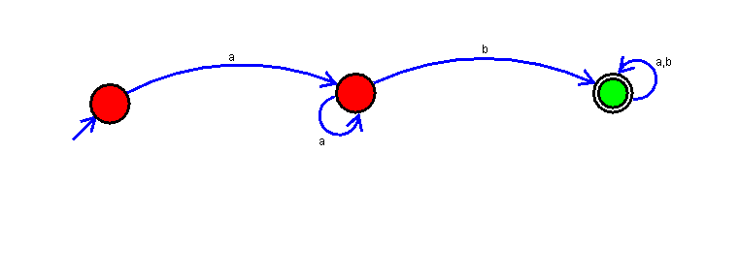

Result:

Successfully executed Deterministic Finite Automata using simulator to accept the string having ‘ab’ as substring over the set {a,b}.